Automation Testing – Selenium Practice

Overview:
This report presents a small practice exercise in test automation using Python and Selenium, conducted on Google search functionality. The activity included both reviewing a sample automation script and observing the automated test suite execution to understand how automation works in practice.
The test suite included two test cases:
- Verifying that the search bar accepts input and returns relevant results.
- Verifying that the page title contains the searched keyword.
This exercise included reviewing the basic structure of the automation script, understanding how the test steps are implemented in code, and observing the execution results of the automated tests, including pass/fail outcomes

Automation Testing Sample Script
Setting Test Configuration:
1- Import Selenium
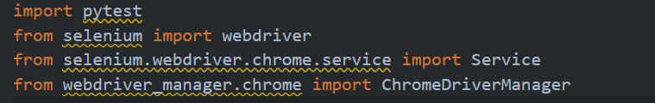
2- Open browser

Test case 1: Checking the search bar works and returns results
1- Open Google
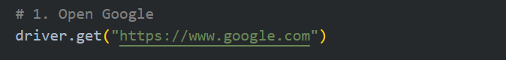
2- Locate elements
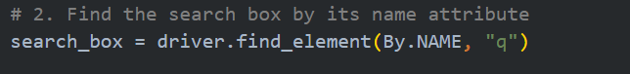
3- Enter data
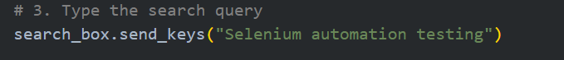
4- Press Enter
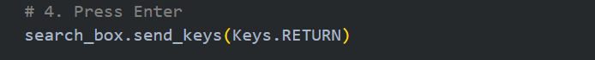
5- Validate result
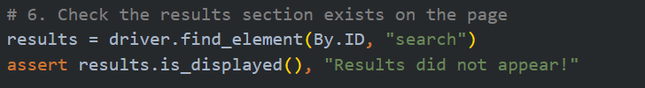
6- Observe Test Result
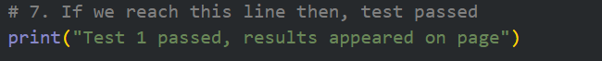
7- Close browser
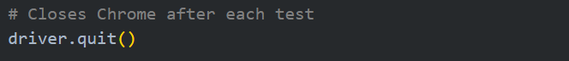

Test case 2: Checking the page title contains what you searched for
1- Open Google
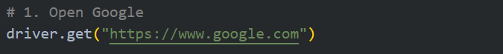
2- Locate Elements
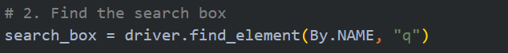
3- Enter Data
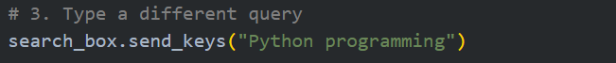
4- Press Enter
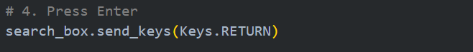
5- Validate Results
6- Observe Test Result
7- Close browser

Line-by-Line Explanation
Command | Main Functionality
driver.get(url) | It opens a URL in Chrome, like typing it in the address bar
find_element(By.NAME, 'q') | It finds the HTML element that has the attribute name='q' which is Google's search box
send_keys('text') | It types text into an input field, just like a user typing on a keyboard
send_keys(Keys.RETURN) | It simulates pressing the Enter key to submit the search
find_element(By.ID, 'search') | It finds the element with id='search' which is Google's results container
assert condition, message | It is the actual test check. If the condition is False, the test FAILS with the given message
driver.title | It gets the current browser tab title
driver.quit() | It closes the Chrome window and cleans up all resources

Code Script
conftest.py File:
import pytest
from selenium import webdriver
from selenium.webdriver.chrome.service import Service
from webdriver_manager.chrome import ChromeDriverManager

@pytest.fixture
def driver():
# Opens Chrome before each test
driver = webdriver.Chrome(service=Service(ChromeDriverManager().install()))
driver.implicitly_wait(10) # wait up to 10s for any element to appear
driver.maximize_window() # full screen so you can see everything

yield driver # hand the browser to the test

# Closes Chrome after each test
driver.quit()
test_google.py File:
from selenium.webdriver.common.by import By
from selenium.webdriver.common.keys import Keys
import time

# Test Suite: Google Search Bar
class TestGoogleSearch:

# test case 1: checking if the search returns results
def test_search_returns_results(self, driver):

# Open Google
driver.get("https://www.google.com")

# Find the search box by its name attribute
search_box = driver.find_element(By.NAME, "q")

# Type the search query
search_box.send_keys("Selenium automation testing")

time.sleep(5)

# Press Enter
search_box.send_keys(Keys.RETURN)

# Pause 10 seconds to observe the results on screen
time.sleep(10)

# Check the results section exists on the page
results = driver.find_element(By.ID, "search")
assert results.is_displayed(), "Results did not appear!"

# If we reach this line then, test passed
print("Test 1 passed, results appeared on page")

# test case 2: checking if the page title matches the query
def test_page_title_matches_query(self, driver):

# Open Google
driver.get("https://www.google.com")

# Find the search box
search_box = driver.find_element(By.NAME, "q")

# Type a different query
search_box.send_keys("Python programming")

time.sleep(5)

# Press Enter
search_box.send_keys(Keys.RETURN)

# Pause 10 seconds to observe the page title changing
time.sleep(10)

# Check that the browser tab title contains our search word
assert "Python" in driver.title, "Title did not match the search query!"

# Print the actual title so you can see it in the terminal
print(f"Test 2 passed, page title is: '{driver.title}'")

Observing the Test Suite Run
As soon as we run the command, we will see the following happen on the screen:
- Chrome opens automatically
- Test Case 1 starts: Google homepage appears
- The text 'Selenium automation testing' types itself into the search box
- Enter is pressed automatically and results load
- Chrome closes, then opens again fresh for Test Case 2
- 'Python programming' types itself and the search runs
- Chrome closes automatically
- Terminal shows the final report

Test case 1 Observation Results
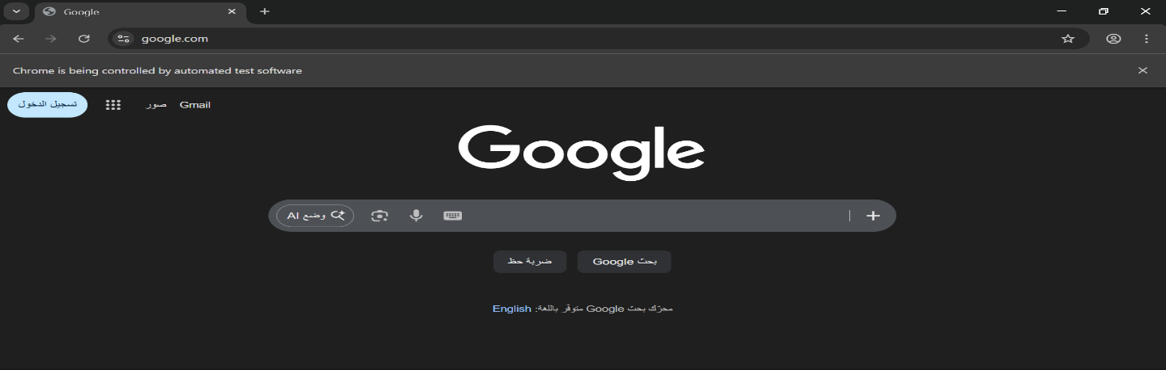
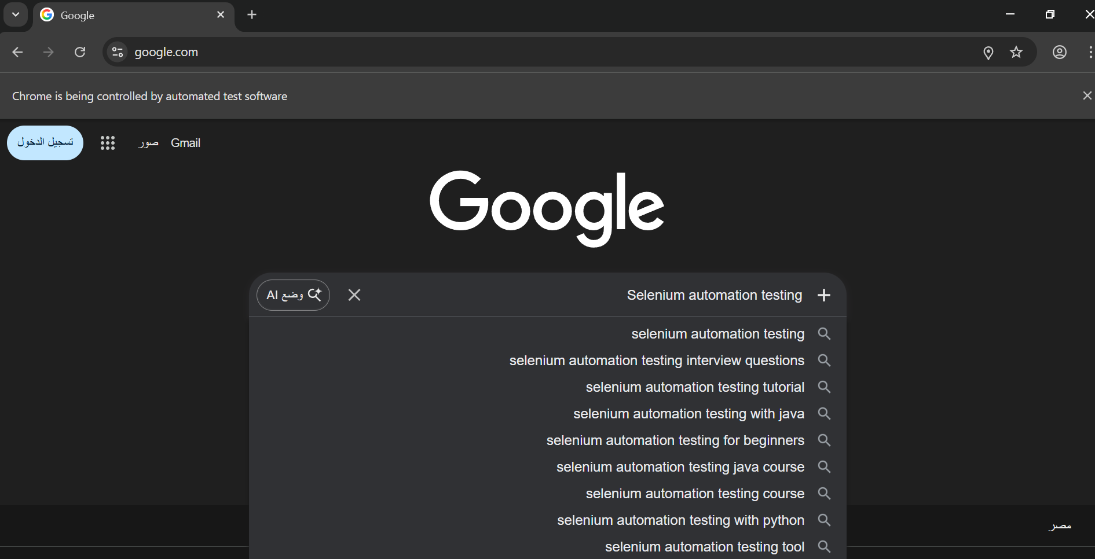
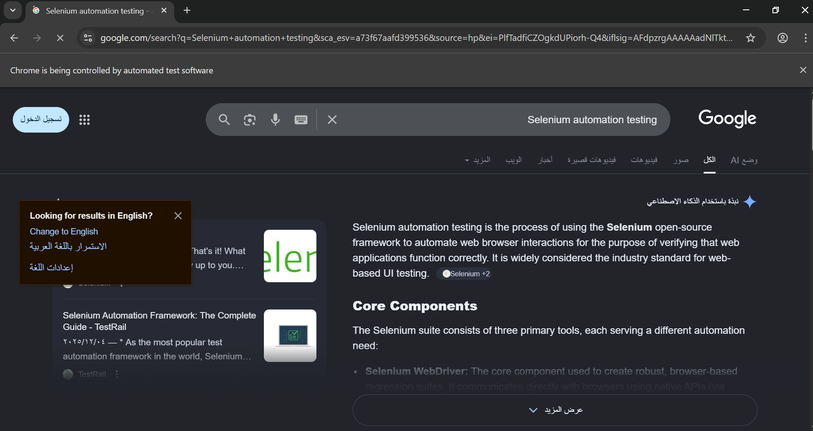

Test Case 2 Observation Results
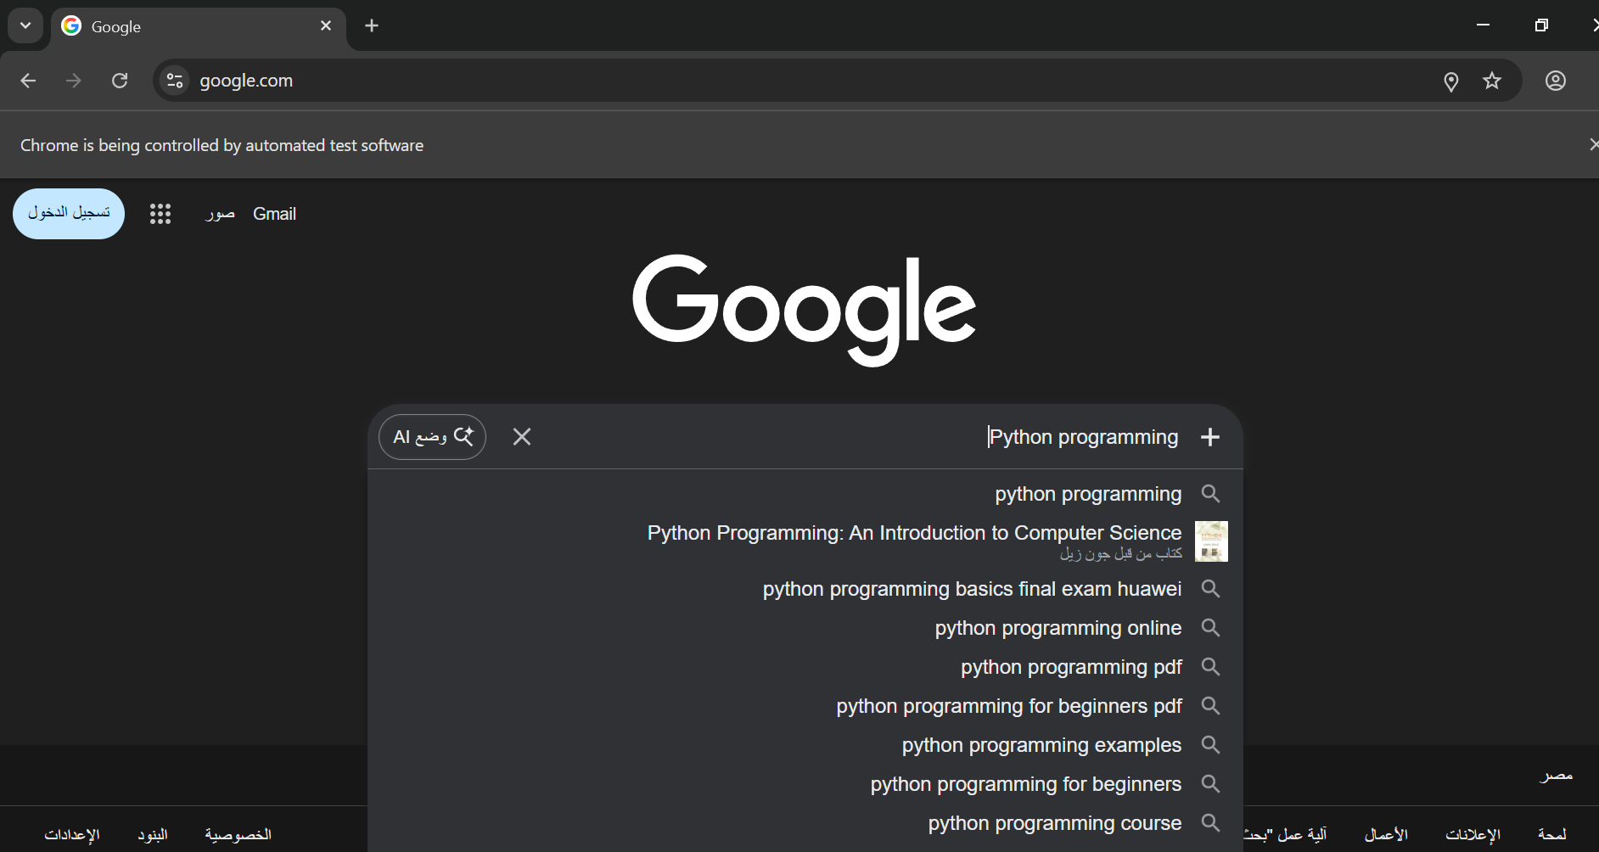
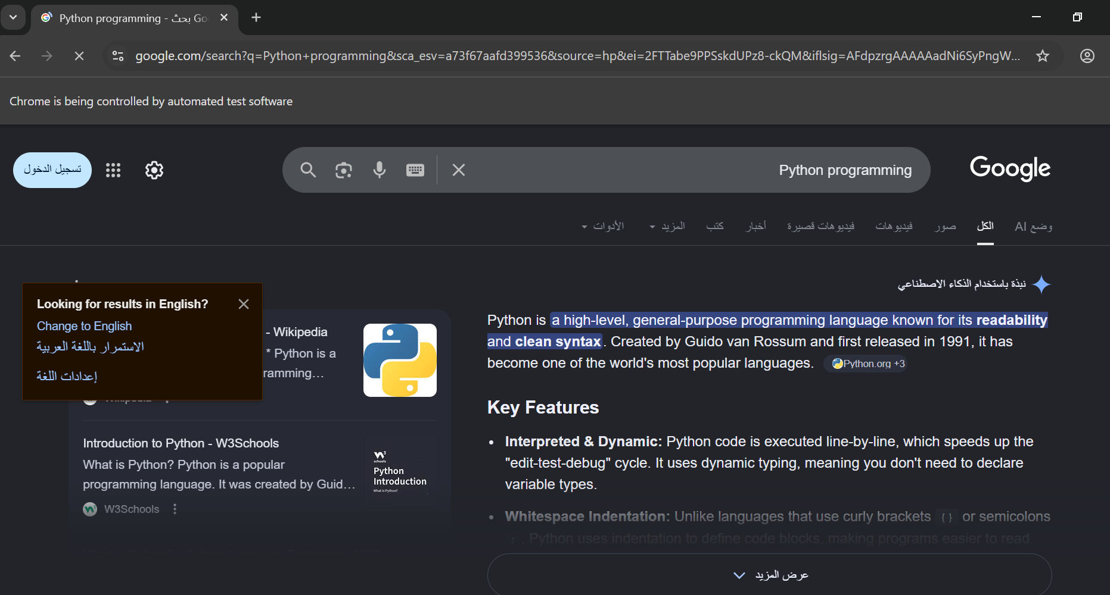

Testing Results
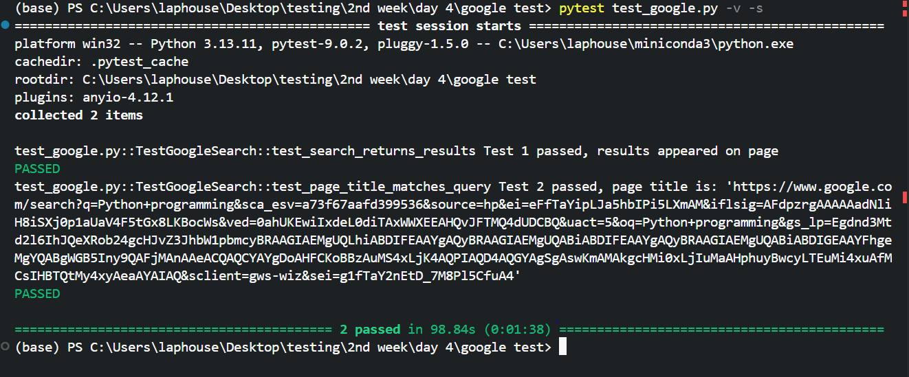
As shown above, the two test cases have been passed

